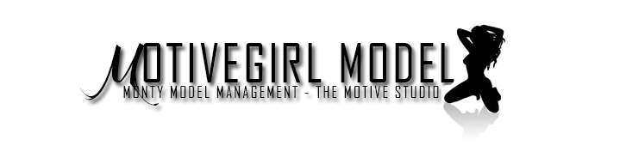
Thank you for your interest in joining The MotiveGirls Club. We are looking forward to representing you and assisting in building your modeling career. The MotiveGirls Club has associations with a large amount of marketing companies, Brand sponsors, and production companies nationwide. And being in existence for over 5 years, we strive to not only be the best, but to be one of the only top agencies in our genre.
Why should you let us represent you? Here at The MotiveGirls Club, we run our organization with family like values. And we all know that family comes first. Along with loyalty and consistency, this is what allows our company to be so strong. We have head models that also act as our agents in every major city nationwide to assist all our new talent. We also have photographers in every major city that assist in portfolios and content building for all our talents.
Because we work alongside of other companies and brands, there is always paid work for all our clients. Photo Shoots, Event hosting, Music Videos, Parties, And Radio Interviews to say the least.
The MotiveGirls Club is not your typical agency; we work hands on with all our talent to make sure they have everything they need aide in making your career as strong as possible. One thing to remember, we can only work for you as much as you allow us to. We will provide as much guidance as possible, but we are unable to hold your hand. As one of our talents it is our job to put your needs first.
It is time for you become a part of something great and everlasting as we plan to continue to take this industry off of its feet. No more excuses or reasons why you cannot be a successful talent. Are you ready? We are.

Monty
CEO – The MotiveGirls Club
www.themotivegirlsclub.com
themotivemag@gmail.com

